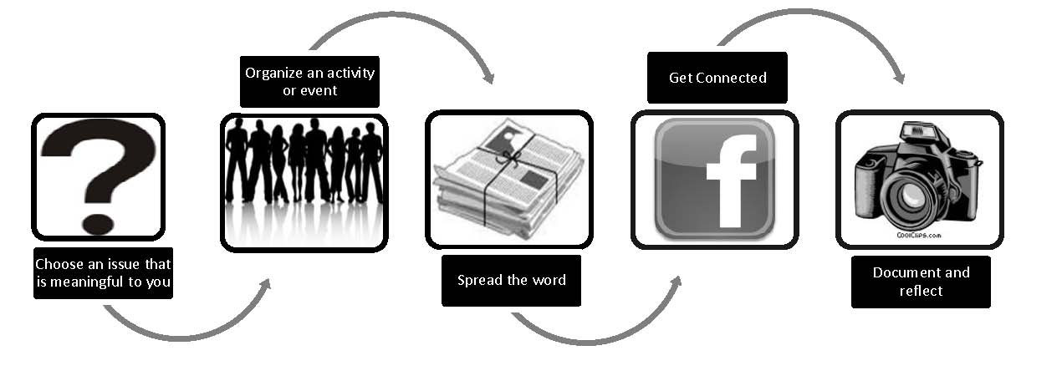
If you are new to the 16 Days Campaign, this document offers a few suggestions of how to get involved. No matter which actions you take on for this year’s 16 Days Campaign, please remember to report your activities and send photos and samples of your campaign materials to CWGL for inclusion in the 2010 International Calendar of Activities and the archives. Thank you!
- Choose an Issue that is Meaningful to You
Start by reading through the campaign theme announcement. Reflect on which issues are most interesting or relevant for you. The 16 Days Bibliography & Resource List in this kit will help you locate additional resources available online. Before you begin planning your campaign, here are some questions and issues to consider:
- What sparked your initial interest in working on the 16 Days Campaign?
- How do the issues raised in the theme announcement relate to your own life experiences? Do you see any relationship? Why or why not?
- Considering that we all live in a militarized world, what are some of the subtle and obvious ways that militarism has affected you, your family, your friends, or your community?
- What types of violence do women and girls in your community face?
- Are there any policies or laws in place to protect women and girls from these forms of violence and discrimination?
- Consider the links between what happens at local, national and global levels. Since violence against women knows no boundaries of nation, culture, community, race, sexual orientation, or religion, what is similar about this violence?
- Are there other organizations or individuals working on these issues that you can partner with on the campaign? Look for listserves and online communities you can join to receive more information. You can start with the 16 Days listserve! (Subscribe here: https://email.rutgers.edu/mailman/listinfo/16days_discussion)
- Create clear goals for your campaign activities: Who do you want to reach? What changes do you want to make (e.g. changes in or support for laws or policies, funding dedicated to a particular issue, changes in people’s perceptions and attitudes, support for survivors of violence)? What are the needs of those affected by violence?
2. Organize an Event or Activity
Once you determine the issue you would like to focus on with your campaign activities, you might consider planning an event or activity this year. The possibilities are endless – just make sure to be creative and strategic with your campaign! Here are some suggestions on how to get started:
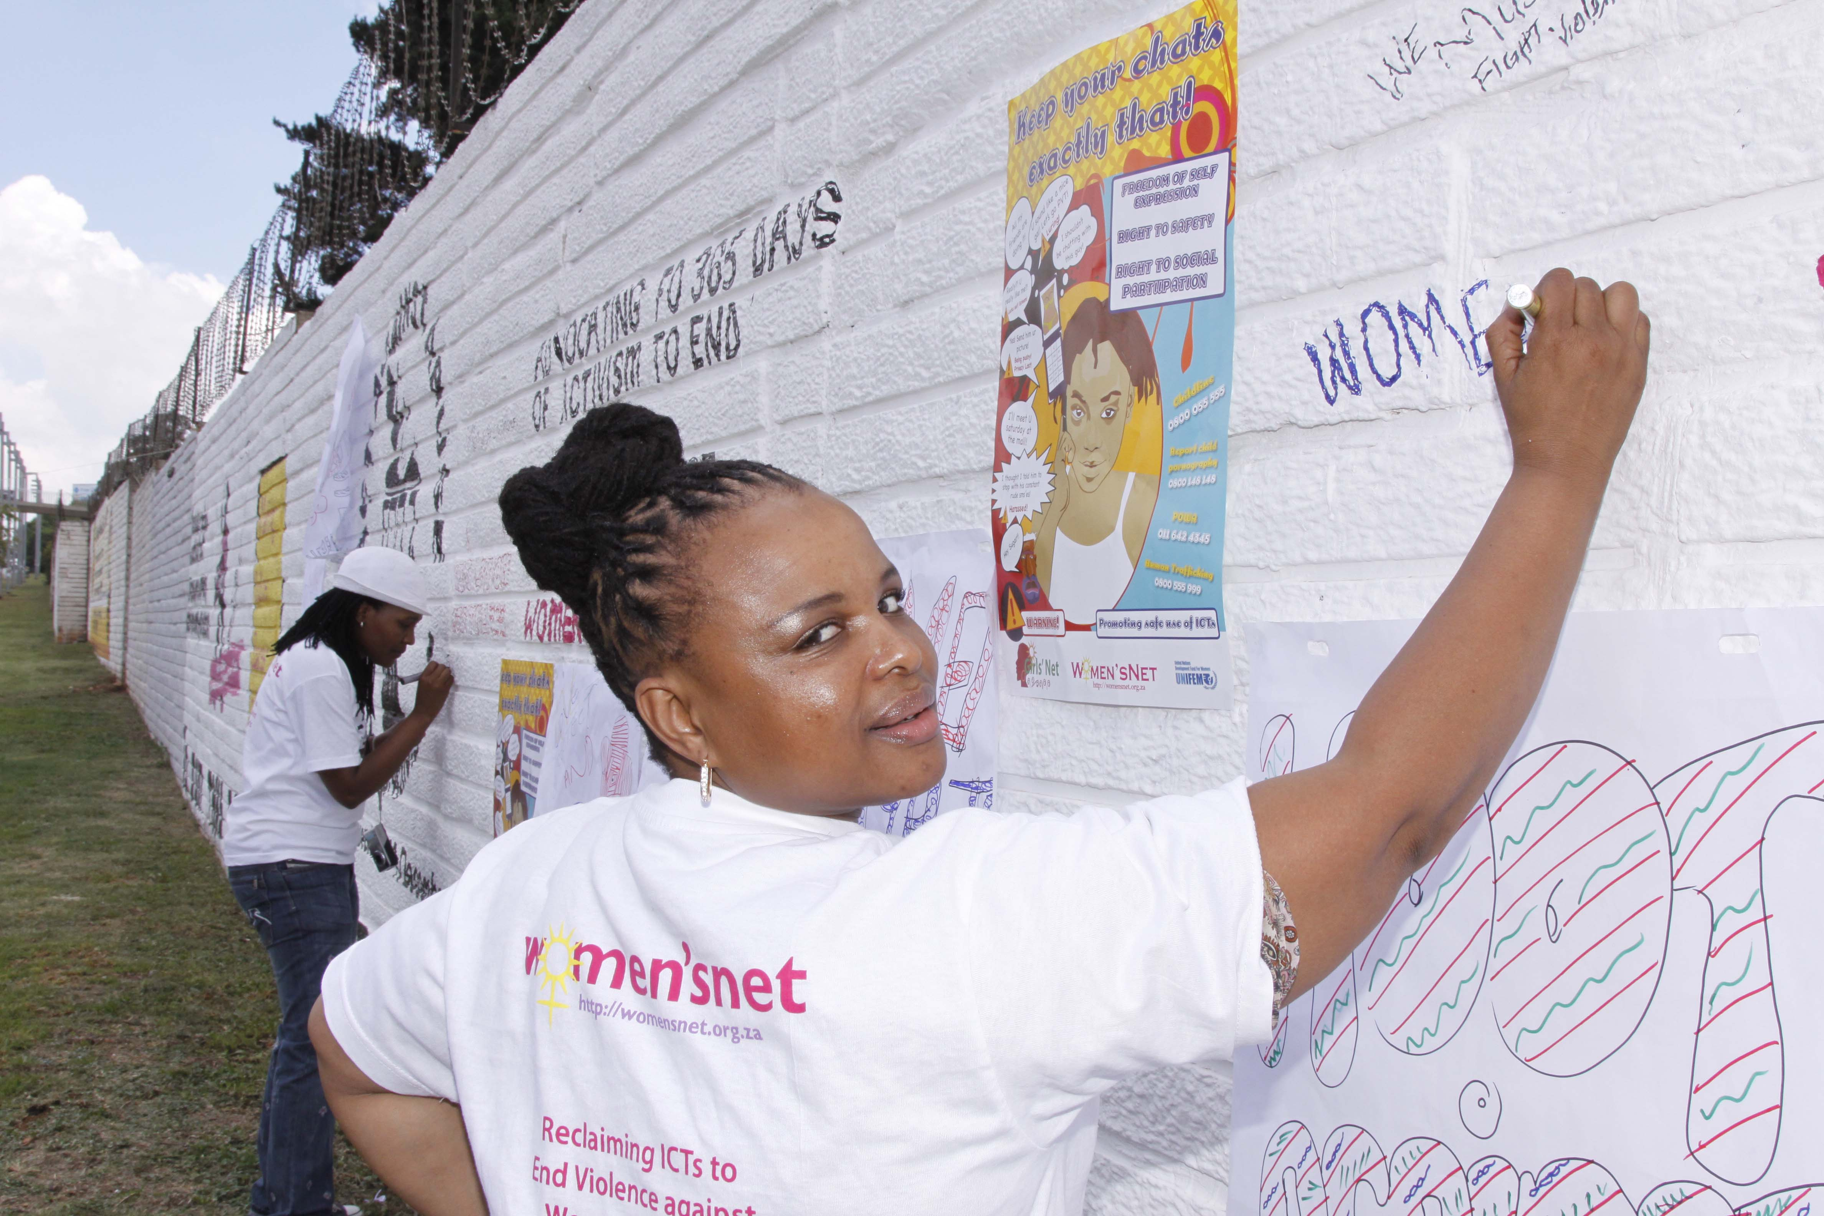
© Women’sNet (2009) South Africa

Raise awareness!
Host a dinner, group discussion, or a film screening • Give presentations or host workshops in schools and universities • Distribute leaflets, pamphlets, and books • Write articles for newspapers, journals, blogs, and newsletters • Plan an international event or conference where you invite activists from around your country, region or the world to participate • Reach out to faith-based communities and ask them to share information with their constituents • Commemorate key international dates during the 16-day time period and highlight their significance vis-à-vis violence against women (see Key Dates document in kit).

Be creative!
Publish a magazine, poetry collection, calendar, or cartoons • Paint peace murals • Organize street plays, theater performances, humorous skits, role-playing exercises, festivals, or music or dance performances • Initiate a poster, essay or public-speaking contest • Distribute awards for community role models.

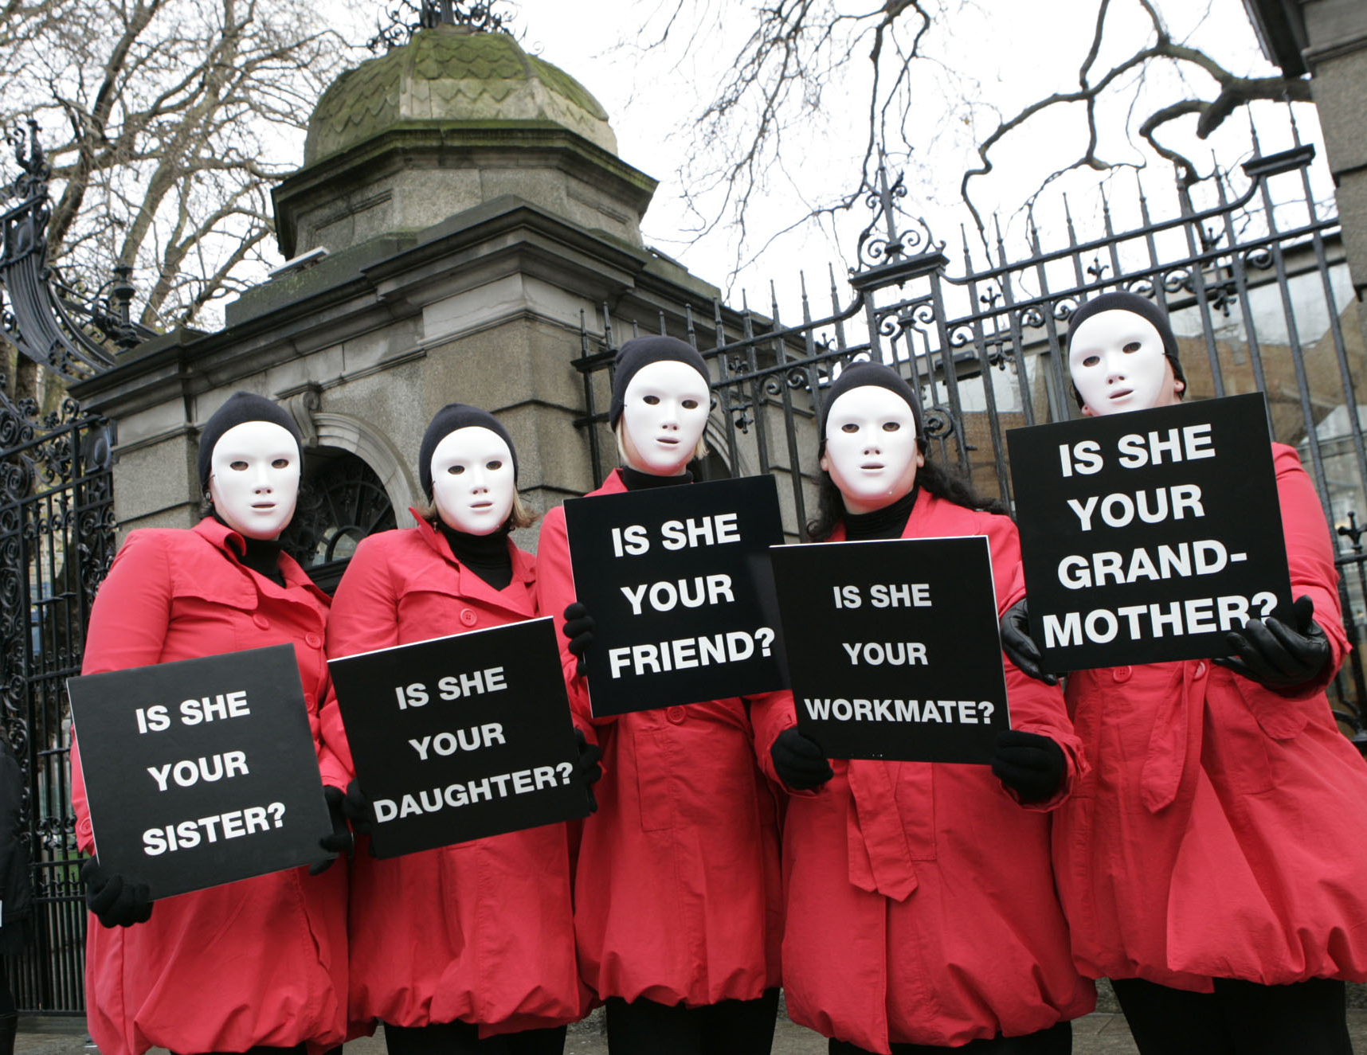
©Women’s Aid Ireland (2009)

Engage in e-Activism!
Start a blog (e.g. Blogger, Wordpress, Weebly, Tumblr, MSNspaces, WorldPulse) to discuss violence against women and share resources • Become a fan of “The Official 16 Days of Activism Against Gender Violence Campaign” Facebook fan page • Upload photos • Participate in discussion boards • Sign or start your own online petitions • Record your own music or create videos for advocacy on human rights and share them on the 16 Days Facebook page • Add interactive tools to your website, such as polls, surveys or maps • Take Back the Tech!

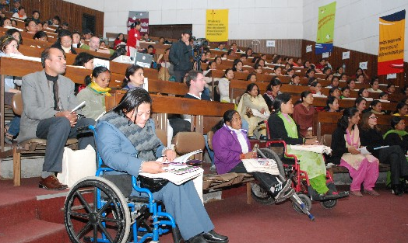
© WOREC
Nepal (2008)
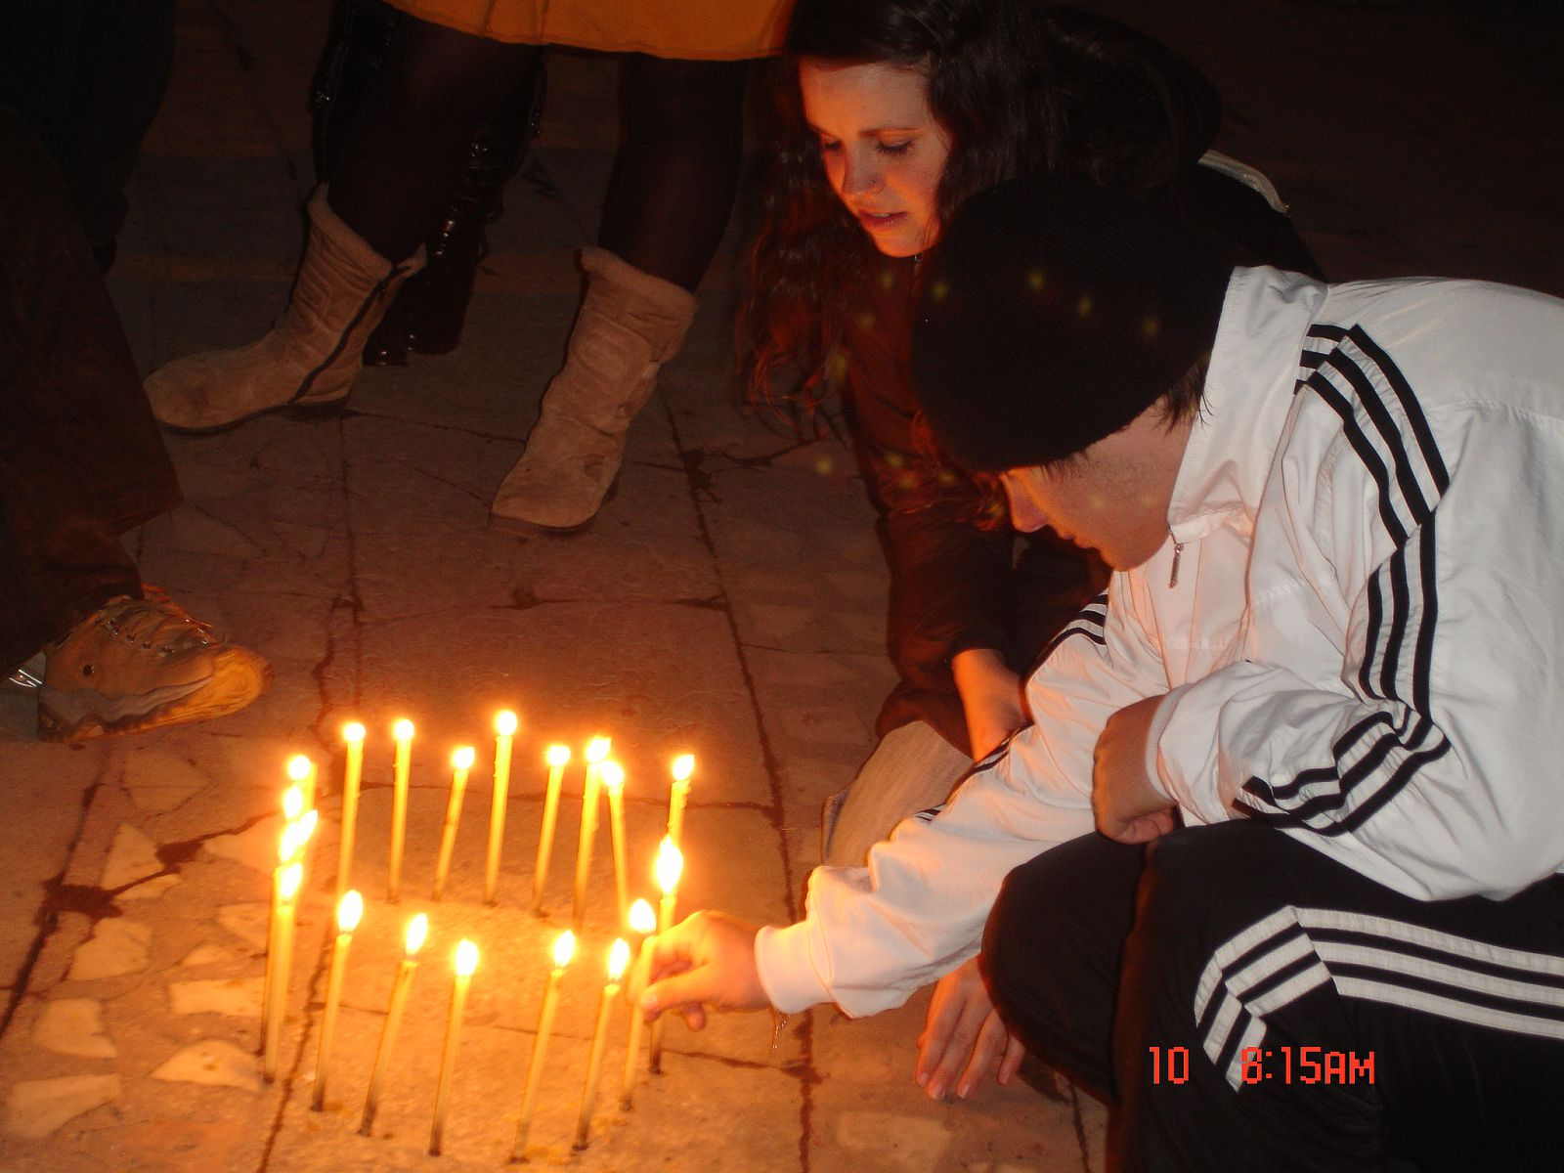
© U.S. Peace Corps, Romania (2009)

Support survivors!
Volunteer at a community organization that works with victims of violence • Plan a Take Back the Night event or provide safe spaces where survivors can speak out about their abuse • Do outreach work with organizations that provide direct-service for survivors and encourage them to integrate awareness and prevention work on VAW into their services • Organize a fundraiser and donate the proceeds to a local domestic violence shelter.

Build skills!
Organize skills-building workshops, leadership trainings, webinars, or gender awareness programs for activists, women human rights defenders, youth, police, teachers, health care providers, and other professionals.


© EME (2008) Chile

Involve New Partners!
Invite men and boys to be part of the campaign • Bring friends and family members to 16 Days events with you • Reach out to people of different generations and communities and other new partners (e.g. political groups, local businesses and unions, faith-based organizations, development NGOs, service-providers, professionals in the corporate sector, etc.) to involve them in planning activities.

Fundraise!
Plan an event and donate the proceeds to a cause or an organization that assists survivors of violence: Auctions, Bake Sales, Bazaars, Benefit Performances & Concerts, Charity Sales, Art Exhibition, Dinner with discussion/guest speaker, Craft Sales, Dances, Fashion Show, Marathons, Sponsored Walks, Raffles/ Lotteries, Sports Events with Sponsors, Selling Tickets for a theater play/dance/film, Street Fairs/Carnivals.

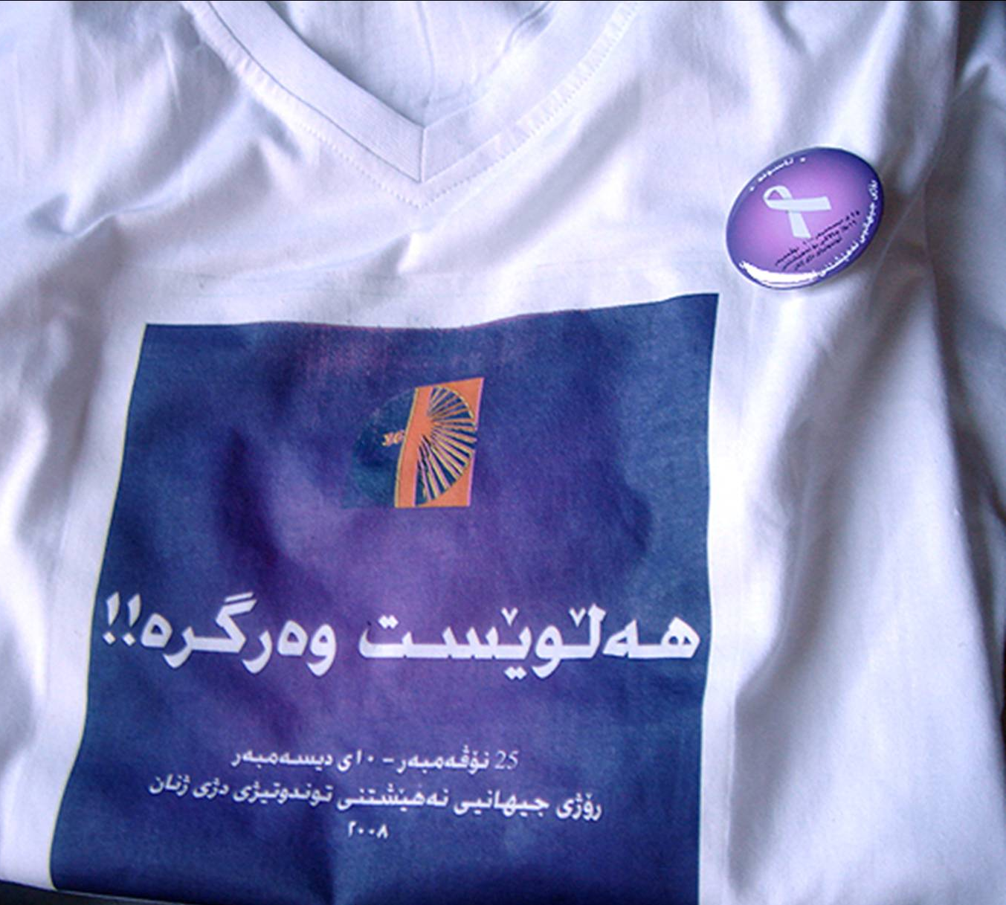
© Asuda for Combating Violence Against Women (2008) Iraq
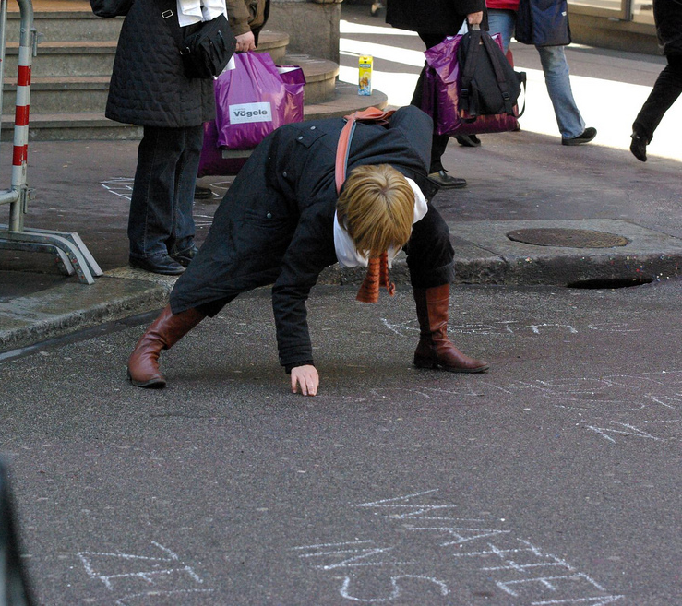
© cfd (2009) Switzerland

Be visible!
Take over public spaces by chalking sidewalks and hanging colorful banners, posters, and flags • Distribute stickers, white or purple ribbons, and other visible symbols against violence to people on the street • Make silhouettes to represent the number of victims of violence and display them in public • Utilize slogans, caricatures, and symbols.

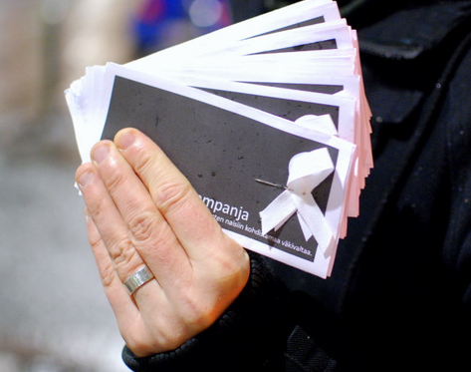
© Profeministimiehet (2009) Finland

Get political!
Put pressure on politicians, administrators, and other decision-makers to demand changes • Organize mass petition drives, letter-writing campaigns, sit-ins, boycotts, student strikes, silent protests, teach-ins • Write to local leaders and request that they issue a proclamation to officially recognize the 16 Days of Activism in your community • Remind States that they are bound by international human rights law to ensure that all persons are able to enjoy their fundamental human rights (Check the UN Treaty Collection to see if your government is party to all human rights conventions and covenants and if they are not then lobby them to ratify these treaties without reservations.).

Make some noise!
Plan public speeches, marches, rallies, protests, or vigils honoring victims of violence • Use drums and other instruments in your activism • Make appearances on radio and television broadcasts • Take out advertisements in visible, public spaces.

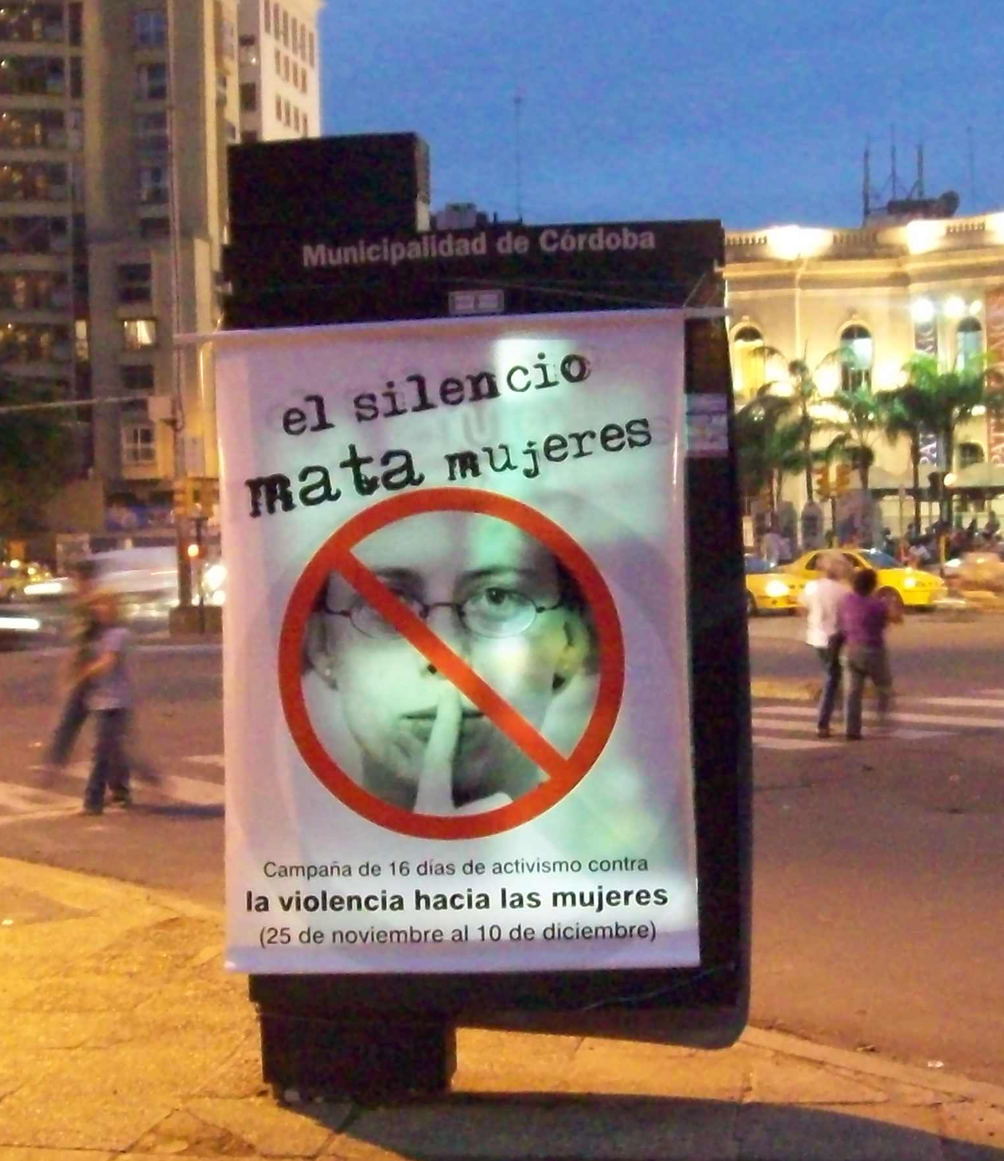
© Hilando las Sierras (2009) Argentina

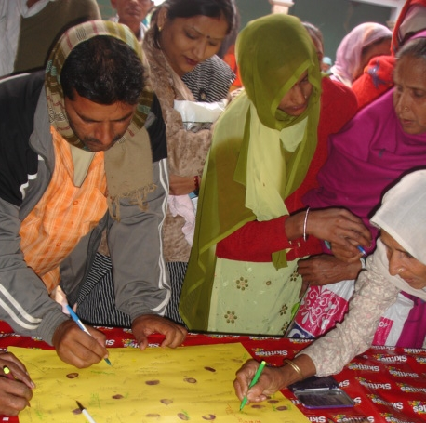
© IRRAD (2009) India

2010 Theme-Specific Campaign Activities
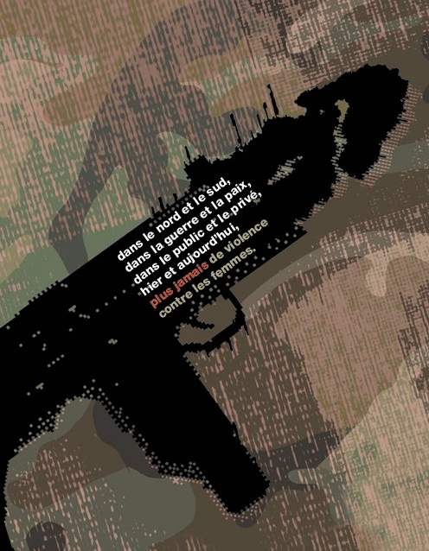
© Marche Mondiale des femmes
  - Participate in the November 29th Global Action against Militarism and Violence Against Women (see the event and media documents in the Take Action Kit).
  - Send CWGL a personal reflection piece about this year’s theme to share with other campaign participants.
  - Organize a peace rally or a non-violence training: http://www.wri-irg.org/pubs/NonviolenceHandbook.
  - Plan an Anti-Militarism Fashion Show to raise awareness about military spending and the ways militarism influences our lives.
  - “Invite women (from different sides of a conflict) in your community to come together in order to explore ways to reduce tensions within the community or neighborhood and to work together on peacebuilding and gender justice. Ask them what kinds of violence they experience and how they deal with that.” (From Together for Transformation by IFOR WPP)
  - “Talk with men in your community about their experiences with violence. Ask them how they would like to contribute to the eradication of this violence. Invite them to start or participate in a men’s group that works on promoting gender justice and eradicating violence against women. Encourage them to link with other men’s groups to exchange strategies and lessons learned.” (From Together for Transformation by IFOR WPP)
  - Find out what your government is doing to implement UN Security Council Resolution 1325 and its related commitments on women, peace and security (1820, 1888, and 1889). Does your government ensure it concretely supports women's empowerment in peace processes as fundamental to its foreign policy? Does it ensure that any aid for post-conflict re-building includes specific funding for women? Is your country taking its obligations to women in conflict seriously by making sure it regularly consults with women's rights advocates on all of its security sector planning, both foreign and domestic? http://www.womenpeacesecurity.org/
  - Investigate your government’s military spending and compare it to spending on economic, social, and environmental programs and foreign development aid. For sample letters, talking points, and suggested questions, see the Military Spending Toolkit produced by Reaching Critical Will: http://www.reachingcriticalwill.org/political/milex/MilSpendKit.pdf.
  - Campaign for an international Arms Trade Treaty (ATT) to curb the proliferation of arms leading to violence against women and other human rights abuses (Control Arms campaign: http://www.controlarms.org/).
  - Invest in programs and activities that educate youth about violence prevention and peace building http://www.unicef.org/lifeskills/index_violence_peace.html.
General VAW Campaigning Resources
- Gender Based Violence Prevention Network - Materials from previous & current 16 Days Campaigns: www.preventgbvafrica.org/content/16-days-activism-campaigns
- Say NO - UNiTE Action Ideas: www.saynotoviolence.org/join-say-no/start-action/action-ideas
- Tactical Technology : http://www.tacticaltech.org/toolkits
- Take Back the Tech - Tips for planning online 16 Days Campaign activities: www.takebackthetech.net/
- UNIFEM’s Global Virtual Knowledge Center to End Violence Against Women & Girls: www.endvawnow.org/
- WITNESS - Resources on video advocacy http://witnesstraining.wordpress.com/
Theme-Specific Campaigning Resources
- AFSC Youth and Militarism Program: http://afsc.org/program/youth-and-militarism-program
- CodePink - Resource Toolbox: www.codepink4peace.org/article.php?list=type&type=75
- IANSA - Together We Can Make A Difference! (English/Spanish/French): http://www.iansa-women.org/node/58
- IFOR Women Peacemakers Program - Together for Transformation: Men Masculinities and Peacebuilding: www.ifor.org/WPP/may-pack-2010_web.pdf
- INCITE! Women of Color Against Violence - Anti-militarism organizing resources: www.incite-national.org/index.php?s=55
- Global Network of Women Peacebuilders: http://www.gnwp.org/
- Training for Change: http://www.trainingforchange.org/tools/Nonviolent%20Action%20for%20Social%20Change
- Women in Black - Information on how to hold a vigil: www.womeninblack.org/en/startavigil
- Women’s International League for Peace and Freedom: http://www.peacewomen.org/

3. Spread the word
Print, radio, television and virtual media sources continue to play a major role in shaping opinions and in communicating issues of importance to audiences. It is important for activists to engage with the media both as a target and also as a conduit for carrying campaigning messages and knowledge about women’s human rights. Working with women’s and community-based media networks to develop your campaign media strategy is a great way to get started and build partnerships. For sample letters and further suggestions on how to engage with media, see the Media Tools document in the 2009 Take Action Kit. Some ways you can actively engage with and help shape media coverage on violence against women include:
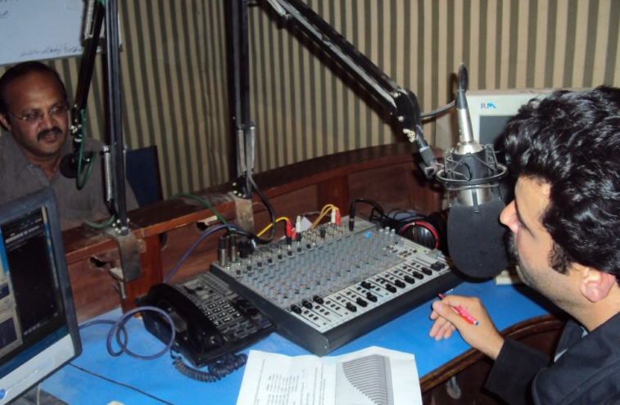
© PADO (2009) Pakistan

Traditional Media
- Write opinion pieces for local newspapers on incidents of violence that have occurred or on state policies and procedures that have a direct impact on the prevalence of violence against women. It is important to critique bad policies and reactions as well as to write in support of good measures and best practices. (Note: if you face any risk of threats or harassment you can write in anonymously or use fictional names).
- Write a press release, inviting the media to cover events you plan during the 16 Days to publicize your work and raise awareness about why ending violence against women is important.
- Call radio talk shows or create and share podcasts. For examples and ideas, visit the Feminist International Radio Endeavour (FIRE) http://www.fire.or.cr or AMARC Women’s International Network (an international NGO serving the community radio movement): http://win.amarc.org/
- Talk to Local Media
  - Approach media outlets to ask if they would be willing to run a special series on the 16 Days. You can also see if they are willing to do a special program on one of the significant dates, such as International Day to Eliminate Violence Against Women, World AIDS Day, International Women Human Rights Defenders Day or Human Rights Day.
  - Target mainstream news sources that cover local, national and global news as well as media outlets that are not strong on communicating about women’s rights and those popular culture media outlets that are listened to by youth.
  - Write to media outlets that you feel are biased in their reporting on violence against women and encourage them to take on a more gender-sensitive approach.

Create a Buzz Online
- If you are a member of a social networking site, change your profile picture to the 16 Days logo (available for download from the 16 Days website) and post status updates about the campaign.
- Join an online discussion group or create webpage to discuss your campaign and share relevant information.
- Write blog articles, opinion pieces, and personal reflections for websites and online information sources.
- Create your own music recordings and videos about the issues your campaign activities will address and share the links through social networking sites.
- Join an online community working to end violence.
- Share, forward, or re-post interesting articles related to violence against women and militarism.
- Tweet with hashtag #16days.
Additional Resources
- Doing Media Advocacy by the International Women’s Health Coalition: http://www.iwhc.org/index.php?option=com_content&task=view&id=3670&Itemid=1292
- Media Tools from the 2009 16 Days Campaign: http://www.cwgl.rutgers.edu/16days/kit09/kit.html
- Campaign Kit from Take Back the Tech: http://www.takebackthetech.net/organise/campaign-kit
- Tools and Tips for Effective E-Activism by Amnesty International: http://www.amnesty.org/en/library/info/ACT70/003/2009/en
- Reporting Gender-Based Violence: A Handbook for Journalists: http://www.ips.org/mdg3/GBV_Africa_LOWRES.pdf
4. Get Connected
- Connect to the international 16 Days Campaign!

- Send us information about your plans for the upcoming 16 Days Campaign for inclusion in the online International Calendar of Campaign Activities. You can also see what people have done in the past by looking at the online calendars from previous campaigns.

- Become a fan of “The Official 16 Days of Activism Against Gender Violence Campaign” Facebook fan page
- Join the 16 Days email discussion listserve to share and receive resources on the global effort to end violence against women and girls: https://email.rutgers.edu/mailman/listinfo/16days_discussion
- Visit the 16 Days Campaign Flickr album to see what other groups have done (Make sure to contact the organizations before using any of their pictures!): www.flickr.com/photos/18578511@N04/
- Research and link with other local organizations or international coalitions that are working on these issues:
- Research what groups are active in your local area and find out if they have a newsletter to which you can subscribe.
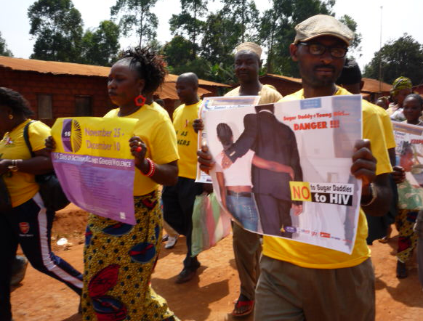
© WACameroon (2009) Cameroon
- Consider becoming a member of organizations that campaign to end violence against women and have local chapters.
- Search for actions, organizations, and resources on the Say NO – UNiTE website http://www.saynotoviolence.org/
- For a list of selected sites on Global Women's Activism, visit: www.libraries.rutgers.edu/rul/rr_gateway/research_guides/womens_studies/activism.shtml
- For a list of other gender-related electronic forums, visit: http://userpages.umbc.edu/~korenman/wmst/forums.html
- Sexual Violence Research Initiative listserve by the Global Forum for Health Research: http://www.svri.org/activities.htm

- Document & Reflect
Make sure to document your action with pictures, summaries of the events, and a commentary on how people reacted or participated. Documentation is useful for media, future campaigning activities, and fundraising.
- When documenting your campaign activities, consider these questions:
    - Do you think the campaign went well? Why or why not?
    - Did you achieve the goals you set in the beginning?
    - What was the impact of your actions?
    - What would you do differently next time?
    - What tools or resources would you require to improve your participation in the campaign?
- Share the summary of your campaign activities by posting it on the web, sending it to other local or national organizations, or publishing it in a newsletter. Remember to send a copy to CWGL, too!
- Complete the 16 Days Campaign Questionnaire in this kit or online – let the Center for Women’s Global Leadership know how we can improve the campaign resources we provide!

Center for Women’s Global Leadership
Rutgers University, 160 Ryders Lane, New Brunswick, NJ 08901-8555 USA
Phone (1-732) 932-8782, Fax: (1-732) 932-1180, E-mail: 16days@cwgl.rutgers.edu
Website: http://www.cwgl.rutgers.edu/16days/home.html

